|  |  |
| --- | --- |
| Ex.no:  Date: | **A User space program to toggle any one of the LED in Rugged Board A5d2x** |

**AIM:**

To Write a user space program to toggle any one of the LED in Rugged Board A5d2x

**ALGORITHM:**

**STEP 1:** Start the program.

**STEP 2:** Include necessary header files for system calls (sys/types.h, sys/stat.h, fcntl.h, unistd.h) and standard I/O operations (stdio.h, string.h, stdlib.h).

**STEP 3:** Define macros for the GPIO paths (GPIO_EN, GPIO_DIR, GPIO_Val) based on the file structure of sysfs.

**STEP 4:**  Define variables: gpio_fd for file descriptors, gpio_buf for storing GPIO number as a string, gpio_num for GPIO pin number, and count for loop iteration.

**STEP 5:** Open the GPIO export file (GPIO_EN) to enable GPIO pins.

**STEP 6:** Write the GPIO pin number to the export file to enable the specified GPIO pin.

**STEP 7:** Close the export file.

**STEP 8:** Open the direction file (GPIO_DIR) of the GPIO pin to set it as an output.

**STEP 9:** Write "out" to the direction file to configure the GPIO pin as an output pin.

**STEP 10:** Close the direction file.

**STEP 11:** Open the value file (GPIO_Val) of the GPIO pin to write values to it.

**STEP 12:** Print a message indicating the GPIO pin toggling will start.

**STEP 13:** Toggle the GPIO pin by writing "0" and "1" alternately to the value file with a delay of 2 seconds using a loop.

**STEP 14:** Close the value file.

**STEP 15:** End the program.

**PROGRAM:**

**blink.c**

#include <sys/types.h>

#include <sys/stat.h>

#include <fcntl.h>

#include <unistd.h>

#include<stdio.h>

#include<string.h>

#include<stdlib.h>

#define GPIO_EN "/sys/class/gpio/export"

#define GPIO_DIR "/sys/class/gpio/PC13/direction"

#define GPIO_Val "/sys/class/gpio/PC13/value"

int blink()

{

int gpio_fd;

char gpio_buf[30];

int gpio_num = 77;

int count =10;

gpio_fd = open(GPIO_EN,O_WRONLY);

if(gpio_fd < 0)

{

printf("Unable to open the file %s\n",GPIO_EN);

exit(0);

}

sprintf(gpio_buf,"%d",gpio_num);

write(gpio_fd,gpio_buf,strlen(gpio_buf));

close(gpio_fd);

gpio_fd = open(GPIO_DIR,O_WRONLY);

if(gpio_fd < 0)

{

printf("Unable to open the file %s",GPIO_DIR);

exit(0);

}

write(gpio_fd,"out",3);

close(gpio_fd);

gpio_fd = open( GPIO_Val,O_WRONLY);

if(gpio_fd < 0)

{

printf("Unable to open the file %s",GPIO_Val);

exit(0);

}

printf("Toggling the GPIO_PIN\n");

while(count--)

{

write(gpio_fd,"0" ,1);

sleep(2);

write(gpio_fd,"1" ,1);

sleep(2);

}

close(gpio_fd);

}

**blink.h**

int blink();

**main.c**

#include<stdio.h>

#include "blink.h"

int main()

{

blink();

return 0;

}

**OUTPUT :**

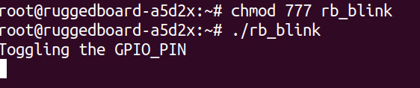

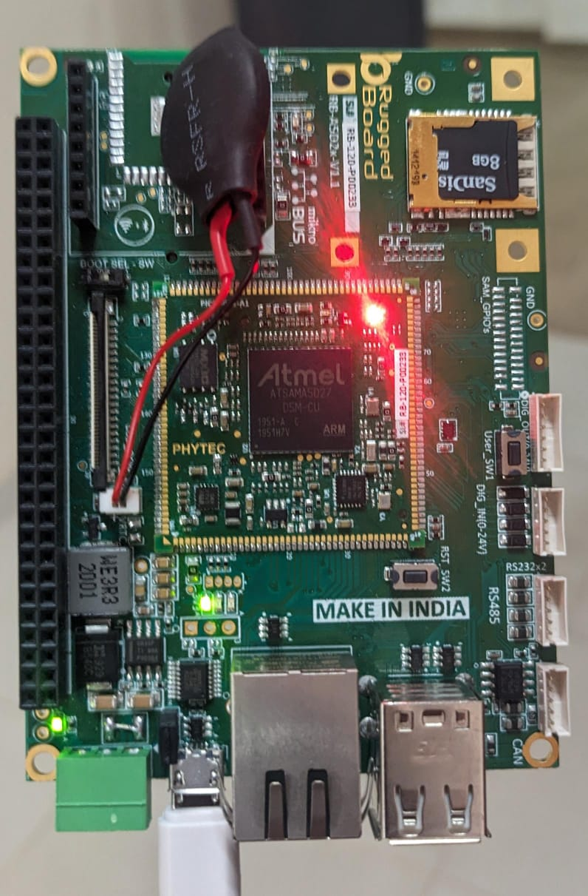

**RESULT:**

|  |  |
| --- | --- |
| Ex.no:  Date: | **A User space program to blink an LED using a user switch using Rugged Board A5D2X** |

**AIM:**

To write a user space program to blink an LED using a user switch using Rugged Board A5d2x.

**ALGORITHM:**

**STEP 1:** Start the program.

**STEP 2:** Include necessary header files for system calls and standard I/O operations.

**STEP 3:** Define macros for the GPIO paths (GPIO_EN, GPIO_DIR, GPIO_Val) based on the file structure of sysfs.

**STEP 4:** Define variables: gpio_fd, fd for file descriptors, gpio_buf for storing GPIO number as a string, gpio_num for GPIO pin number, and value for reading the input GPIO pin value.

**STEP 5:** Open the GPIO export file (GPIO_EN) to enable GPIO pins.

**STEP 6:** Write the GPIO pin number to the export file to enable the specified GPIO pin (PC13).

**STEP 7:** Close the export file.

**STEP 8:** Open the direction file (GPIO_DIR) of the GPIO pin to set it as an output.

**STEP 9:** Write "out" to the direction file to configure the GPIO pin as an output pin.

**STEP 10:** Close the direction file.

**STEP 11:** Open the value file (GPIO_Val) of the GPIO pin to write values to it.

**STEP 12:** Export the second GPIO pin (PC12) and set its direction as input.

**STEP 13:** Read the value of the input GPIO pin (PC12) in a loop and write its value to the output GPIO pin (PC13).

**STEP 14:** Close all file descriptors.

**STEP 15:** End the program

.

**PROGRAM:**

**switch.c**

#include <sys/types.h>

#include <sys/stat.h>

#include <fcntl.h>

#include <unistd.h>

#include<stdio.h>

#include<string.h>

#include<stdlib.h>

#include"userswitch.h"

#define GPIO_EN "/sys/class/gpio/export"

#define GPIO_DIR "/sys/class/gpio/PC13/direction"

#define GPIO_Val "/sys/class/gpio/PC13/value"

int switches()

{

int gpio_fd,fd;

char gpio_buf[30];

int gpio_num = 77;

char value;

gpio_fd = open(GPIO_EN,O_WRONLY);

if(gpio_fd < 0)

{

printf("Unable to open the file %s\n",GPIO_EN);

exit(0);

}

sprintf(gpio_buf,"%d",gpio_num);

write(gpio_fd,gpio_buf,strlen(gpio_buf));

close(gpio_fd);

gpio_fd = open(GPIO_DIR,O_WRONLY);

if(gpio_fd < 0)

{

printf("Unable to open the file %s",GPIO_DIR);

exit(0);

}

write(gpio_fd,"out",3);

close(gpio_fd);

gpio_fd = open( GPIO_Val,O_WRONLY);

if(gpio_fd < 0)

{

printf("Unable to open the file %s",GPIO_Val);

exit(0);

}

fd = open("/sys/class/gpio/export",O_WRONLY);

if(fd < 0)

{

printf("Unable to export the file PC12 \n");

exit(0);

}

write(fd,"76",3);

close(fd);

fd =open("/sys/class/gpio/PC12/direction",O_WRONLY);

if(fd < 0)

{

printf("Unable to open the file direction \n");

exit(0);

}

write(fd,"in",3);

close(fd);

while(10)

{

fd = open("/sys/class/gpio/PC12/value",O_RDONLY);

if(fd < 0)

{

printf("Unable to open the file \n");

exit(0);

}

read(fd,&value,1);

if(value=='0')

write(gpio_fd,"0" ,1);

else

write(gpio_fd,"1" ,1);

close(fd);

}

close(gpio_fd);

}

**switch.h**

int switches();

**main.c**

#include "userswitch.h"

#include <stdio.h>

int main()

{

switches();

return 0;

}

**OUTPUT:**

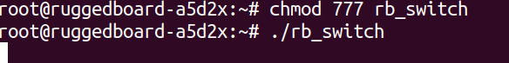

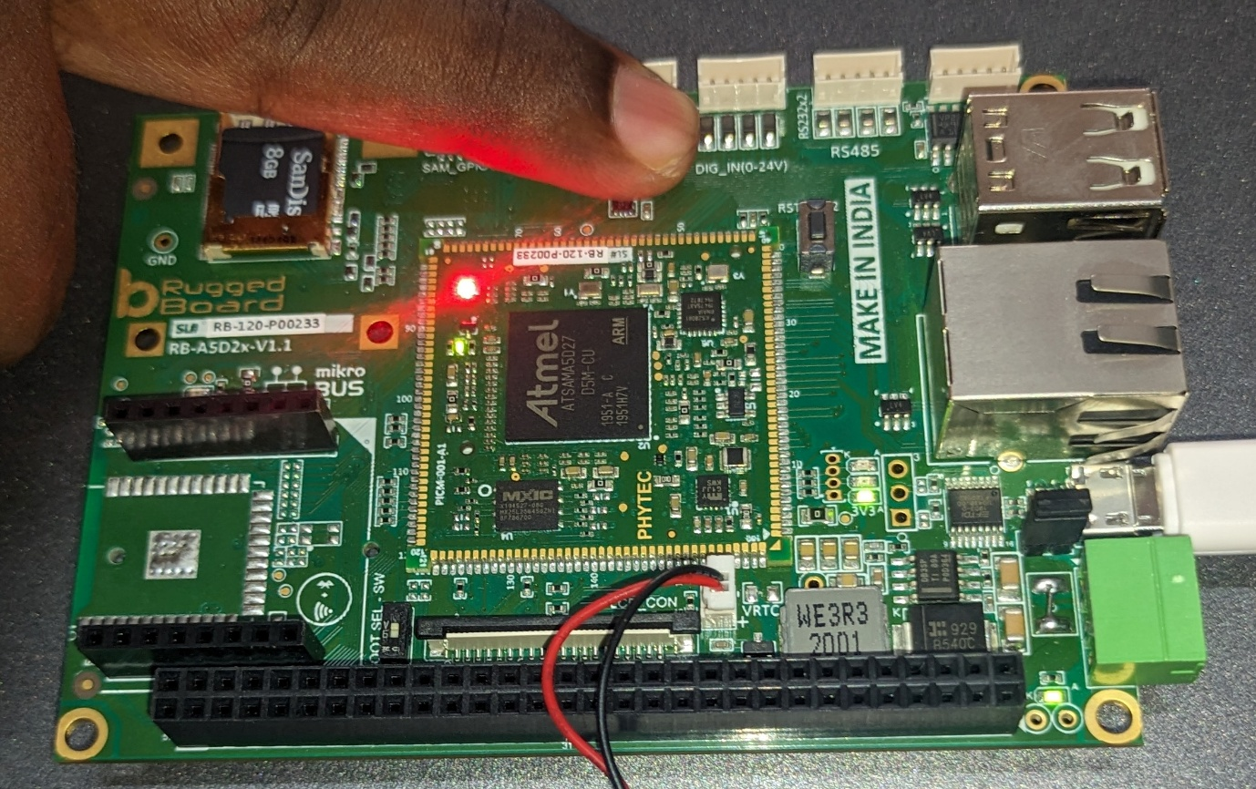

**RESULT:**

|  |  |
| --- | --- |
| Ex.no:  Date: | **A user space program to communicate**  **with uart (transmit) in Rugged Board** |

**AIM:**

To Write a user space program to communicate with uart (transmit).

**ALGORITHM:**

**STEP 1: Prepare the Development Environment:**

- Open terminal and navigate to the directory containing your UART source files (uart_tx.c ).

- Set up the cross-compilation environment for your target platform by executing:

**. /opt/poky-tiny/2.5.2/environment-setup-cortexa5hf-neon-poky-linux-musleabi**

**STEP 2: Compile Source Files:**

- Compile the transmitter (uart_tx.c) source files using the cross-compiler by executing:

${CC} uart_tx.c -o uart_tx

**STEP 3: Copy Executables to Target Board:**

- Copy the compiled executables (uart_tx ) to the TFTP server directory on the target board by executing:

sudo cp uart_tx /var/lib/tftpboot/

**STEP 4: Setup Hardware Connection:**

- Connect the jumper wire from the UART TX pin of the rugged board to the RX pin on the micro bus, effectively creating a loopback connection.

**STEP 5: Configure Rugged Board:**

- Access the terminal of the rugged board and login as root.

- Configure the Ethernet interface with an IP address, for example:

ifconfig eth0 192.168.1.35

- Verify the Ethernet link status.

- Use TFTP to retrieve the transmiter executable (uart_tx) from your development machine to the target board:

tftp -r uart_tx -g 192.168.1.30

**STEP 6: Run Receiver on Rugged Board:**

- Set appropriate permissions for the received executable:

chmod 777 uart_tx

- Execute the receiver program:

./uart_tx

**STEP 7: Transmit Data from Development Machine:**

- On your development machine, execute the transmitter program (uart_tx).

- Enter the string you want to transmit when prompted. For example:

Enter the string to transmit: Hello

**STEP 8: Verify Reception on Rugged Board:**

- Check the rugged board's terminal where the receiver program is running. It should display the received data. For example:

Received: Hello

**PROGRAM:**

**Transmitter_uart.h:**

#ifndef UART_H

#define UART_H

#include <stdio.h>

#include <termios.h>

// Function prototypes

int set_interface_attribs(int fd, int speed);

void uart_transmit(int fd, const char* data, int size);

#endif /* UART_H */

**Transmitter_uart.c:**

#include "transmitter_uart.h"

#include <errno.h>

#include <fcntl.h>

#include <string.h>

#include <unistd.h>

// Function to set serial port attributes

int set_interface_attribs(int fd, int speed) {

struct termios tty;

if (tcgetattr(fd, &tty) < 0) {

printf("Error from tcgetattr: %s\n", strerror(errno));

return -1;

}

cfsetispeed(&tty, (speed_t)speed);

cfsetospeed(&tty, (speed_t)speed);

tty.c_cflag |= (CLOCAL | CREAD); // ignore modem controls, enable receiver

tty.c_cflag &= ~CSIZE; // clear character size mask

tty.c_cflag |= CS8; // 8-bit characters

tty.c_cflag &= ~PARENB; // no parity bit

tty.c_cflag &= ~CSTOPB; // one stop bit

tty.c_cflag &= ~CRTSCTS; // no hardware flow control

tty.c_iflag = IGNPAR; // ignore parity errors

tty.c_oflag = 0; // no output processing

tty.c_lflag = 0; // no input processing

tty.c_cc[VMIN] = 0; // read doesn't block

tty.c_cc[VTIME] = 5; // 0.5 seconds read timeout

if (tcsetattr(fd, TCSANOW, &tty) != 0) {

printf("Error from tcsetattr: %s\n", strerror(errno));

return -1;

}

return 0;

}

// Function to transmit data over UART

void uart_transmit(int fd, const char* data, int size) {

int wlen = write(fd, data, size);

if (wlen != size) {

printf("Error writing to serial port\n");

}

}

**Transmitter_main.c:**

#include "transmitter_uart.h"

#include <stdio.h>

#include <stdlib.h>

#include <string.h>

#include <errno.h>

#include <fcntl.h>

#include <unistd.h>

int main() {

char *portname = "/dev/ttyS3";

int fd;

char input[100]; // Buffer for user input

// Open serial port

fd = open(portname, O_RDWR | O_NOCTTY | O_SYNC);

if (fd < 0) {

printf("Error opening %s: %s\n", portname, strerror(errno));

return -1;

}

// Set serial port attributes

if (set_interface_attribs(fd, B9600) < 0) {

printf("Error setting serial port attributes\n");

close(fd);

return -1;

}

while (1) {

// Get input from user

fgets(input, sizeof(input), stdin);

input[strcspn(input, "\n")] = '\0'; // Remove newline character

// Transmit data

uart_transmit(fd, input, strlen(input));

// Sleep for a short duration before next iteration

usleep(100000); // 100 ms

}

// Close serial port

close(fd);

return 0;

**OUTPUT:**

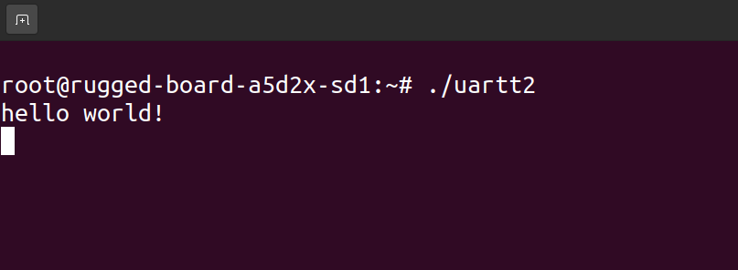

**RESULT:**

|  |  |
| --- | --- |
| Ex.no:  Date: | **A User space program to communicate**  **with uart (receiver) in Rugged Board** |

**AIM:**

To Write a user space program to communicate with uart (receiver).

**ALGORITHM:**

**STEP 1: Prepare the Development Environment:**

- Open terminal and navigate to the directory containing your UART source files (uart_rx.c ).

- Set up the cross-compilation environment for your target platform by executing:

**. /opt/poky-tiny/2.5.2/environment-setup-cortexa5hf-neon-poky-linux-musleabi**

**STEP 2: Compile Source Files:**

- Compile the receiver (uart_rx.c) source files using the cross-compiler by executing:

${CC} uart_rx.c -o uart_rx

**STEP 3: Copy Executables to Target Board:**

- Copy the compiled executables (uart_rx ) to the TFTP server directory on the target board by executing:

sudo cp uart_rx /var/lib/tftpboot/

**STEP 4: Ping the Rugged Board:**

- Open a terminal on your development machine.

- Ping the IP address of the rugged board (192.168.1.35) to ensure connectivity:

ping 192.168.1.35

**STEP 5: SSH into the Rugged Board:**

- SSH into the rugged board using the root account:

ssh [root@192.168.1.35](mailto:root@192.168.1.35)

**STEP 6:TFTP to retrieve the receiver executable:**

- Use TFTP to retrieve the recevier executable (uart_rx) from your development machine to the target board:

tftp -r uart_rx -g 192.168.1.30

**STEP 7: Run Receiver on Rugged Board:**

- In the rugged board's terminal, navigate to the directory where the receiver executable (uart_rx) is located.

- Execute the receiver program:

./uart_rx

Received: hello

- The receiver program will start listening for incoming data.

**PROGRAM:**

**receive_uart.h:**

#ifndef RECEIVE_UART_H

#define RECEIVE_UART_H

#include <stdio.h>

#include <fcntl.h>

#include <string.h>

#include <termios.h>

#include <unistd.h>

#include <errno.h>

// Function prototypes

int set_interface_attribs(int fd, int speed);

void receive_data(int fd);

#endif /* RECEIVE_UART_H */

**receive_uart.c:**

#include "receive_uart.h"

int set_interface_attribs(int fd, int speed) {

struct termios tty;

if (tcgetattr(fd, &tty) < 0) {

printf("Error from tcgetattr: %s\n", strerror(errno));

return -1;

}

cfsetispeed(&tty, (speed_t)speed);

tty.c_cflag |= (CLOCAL | CREAD); /* ignore modem controls */

tty.c_cflag &= ~CSIZE;

tty.c_cflag |= CS8; /* 8-bit characters */

tty.c_cflag &= ~PARENB; /* no parity bit */

tty.c_cflag &= ~CSTOPB; /* only need 1 stop bit */

tty.c_cflag &= ~CRTSCTS; /* no hardware flowcontrol */

tty.c_iflag = IGNPAR;

tty.c_lflag = 0;

tty.c_cc[VMIN] = 1;

tty.c_cc[VTIME] = 1;

if (tcsetattr(fd, TCSANOW, &tty) != 0) {

printf("Error from tcsetattr: %s\n", strerror(errno));

return -1;

}

return 0;

}

void receive_data(int fd) {

unsigned char buf[256];

while (1) {

int rdlen = read(fd, buf, sizeof(buf));

if (rdlen > 0) {

printf("Received: %.*s\n", rdlen, buf);

} else if (rdlen < 0) {

printf("Error reading from serial port\n");

}

}

}

**receive_main.c:**

#include "receive_uart.h"

int main() {

char *portname = "/dev/ttyS3";

int fd;

fd = open(portname, O_RDWR | O_NOCTTY | O_SYNC);

if (fd < 0) {

printf("Error opening %s: %s\n", portname, strerror(errno));

return -1;

}

set_interface_attribs(fd, B9600);

receive_data(fd);

close(fd);

return 0;

}

**OUTPUT:**

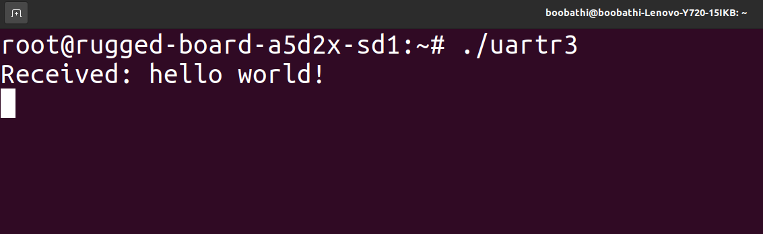

**RESULT:**

|  |  |
| --- | --- |
| Ex.no:  Date: | A **Userspace program to write and read the content of the A5D2x using EEPROM** |

**AIM:**

To write a userspace program to write and read the content of the a5d2x using EEPROM

**ALGORITHM:**

STEP 1: Import necessary libraries for I2C communication, file operations, and error handlingand set the path to the EEPROM file.

STEP 2: Create a structure to represent EEPROM data.

STEP 3: Define a function to read data from the EEPROM file.

STEP 4: Attempt to open the EEPROM file for reading,If opened successfully, read data from the file into the provided structure.

STEP 5: Handle errors during reading.

STEP 6: Define a function to write data to the EEPROM file

STEP 7: Attempt to open the EEPROM file for writing and write data to it.

STEP 8: Start program execution.

STEP 9: Initialize EEPROM data, write it to the EEPROM, and clear the data structure.

STEP 10: Read data from the EEPROM and print it.

**PROGRAM:**

**Board_EEPROM.h**

#ifndef BOARD_EEPROM_H

#define BOARD_EEPROM_H

// EEPROM content format

typedef struct _cBoardEEPROM {

char ModuleID[16];

char SerialNo[16];

char data[512];

} cBoardEEPROM;

// Function declarations

int ReadBoardEEPROM(cBoardEEPROM* boardEEPROM);

void WriteBoardEEPROM(cBoardEEPROM* boardEEPROM);

#endif /* BOARD_EEPROM_H */

#include "board_eeprom.h"

#include <stdio.h>

#include <stdlib.h>

#include <fcntl.h>

#include <unistd.h>

#include <string.h>

#include <errno.h>

// EEPROM path

static const char EEPROM_FILE_BOARD[] = "/sys/class/i2c-adapter/i2c-0/0-0050/eeprom";

// Read board EEPROM

int ReadBoardEEPROM(cBoardEEPROM* boardEEPROM) {

int Fd = 0;

int ReadBytes = 0;

memset(boardEEPROM, 0, sizeof(cBoardEEPROM));

if ((Fd = open(EEPROM_FILE_BOARD, O_RDONLY)) < 0) {

printf("EEPROM_FILE_BOARD open error: %s\n", strerror(errno));

return -1;

}

ReadBytes = read(Fd, (void*)boardEEPROM, sizeof(cBoardEEPROM));

if (ReadBytes < 0) {

printf("EEPROM_FILE_SOM read error: %s\n", strerror(errno));

close(Fd);

return -1;

}

close(Fd);

return 0;

}

**Board EEPROM.c**

// Write board EEPROM

void WriteBoardEEPROM(cBoardEEPROM* boardEEPROM) {

int Fd = 0;

int WriteBytes = 0;

if ((Fd = open(EEPROM_FILE_BOARD, O_WRONLY)) < 0) {

printf("EEPROM_FILE_BOARD open error: %s\n", strerror(errno));

return;

}

WriteBytes = write(Fd, (void*)boardEEPROM, sizeof(cBoardEEPROM));

if (WriteBytes < sizeof(cBoardEEPROM)) {

if (WriteBytes < 0)

printf("EEPROM_FILE_BOARD write error : %s\n", strerror(errno));

else

printf("EEPROM_FILE_BOARD write error : Partial write to EEPROM (%d)\n", WriteBytes);

}

close(Fd);

}

**main.c**

#include <stdio.h>

#include <string.h>

#include "board_eeprom.h"

int main(int argc, char *argv[]) {

int Result = 0;

cBoardEEPROM boardEEPROM, board;

strcpy(boardEEPROM.ModuleID, "RBEEPROM1234");

strcpy(boardEEPROM.SerialNo, "112233445566");

strcpy(boardEEPROM.data, "Phytec Embedded Pvt Ltd");

WriteBoardEEPROM(&boardEEPROM);

memset(&board, 0x00, sizeof(board));

// Read EEPROM

Result = ReadBoardEEPROM(&board);

printf("[EEPROM content]=============================\n");

printf("Module ID : %s\n", board.ModuleID);

printf("Serial NO : %s\n", board.SerialNo);

printf("Data : %s\n", board.data);

return 0;

}

**OUTPUT:**

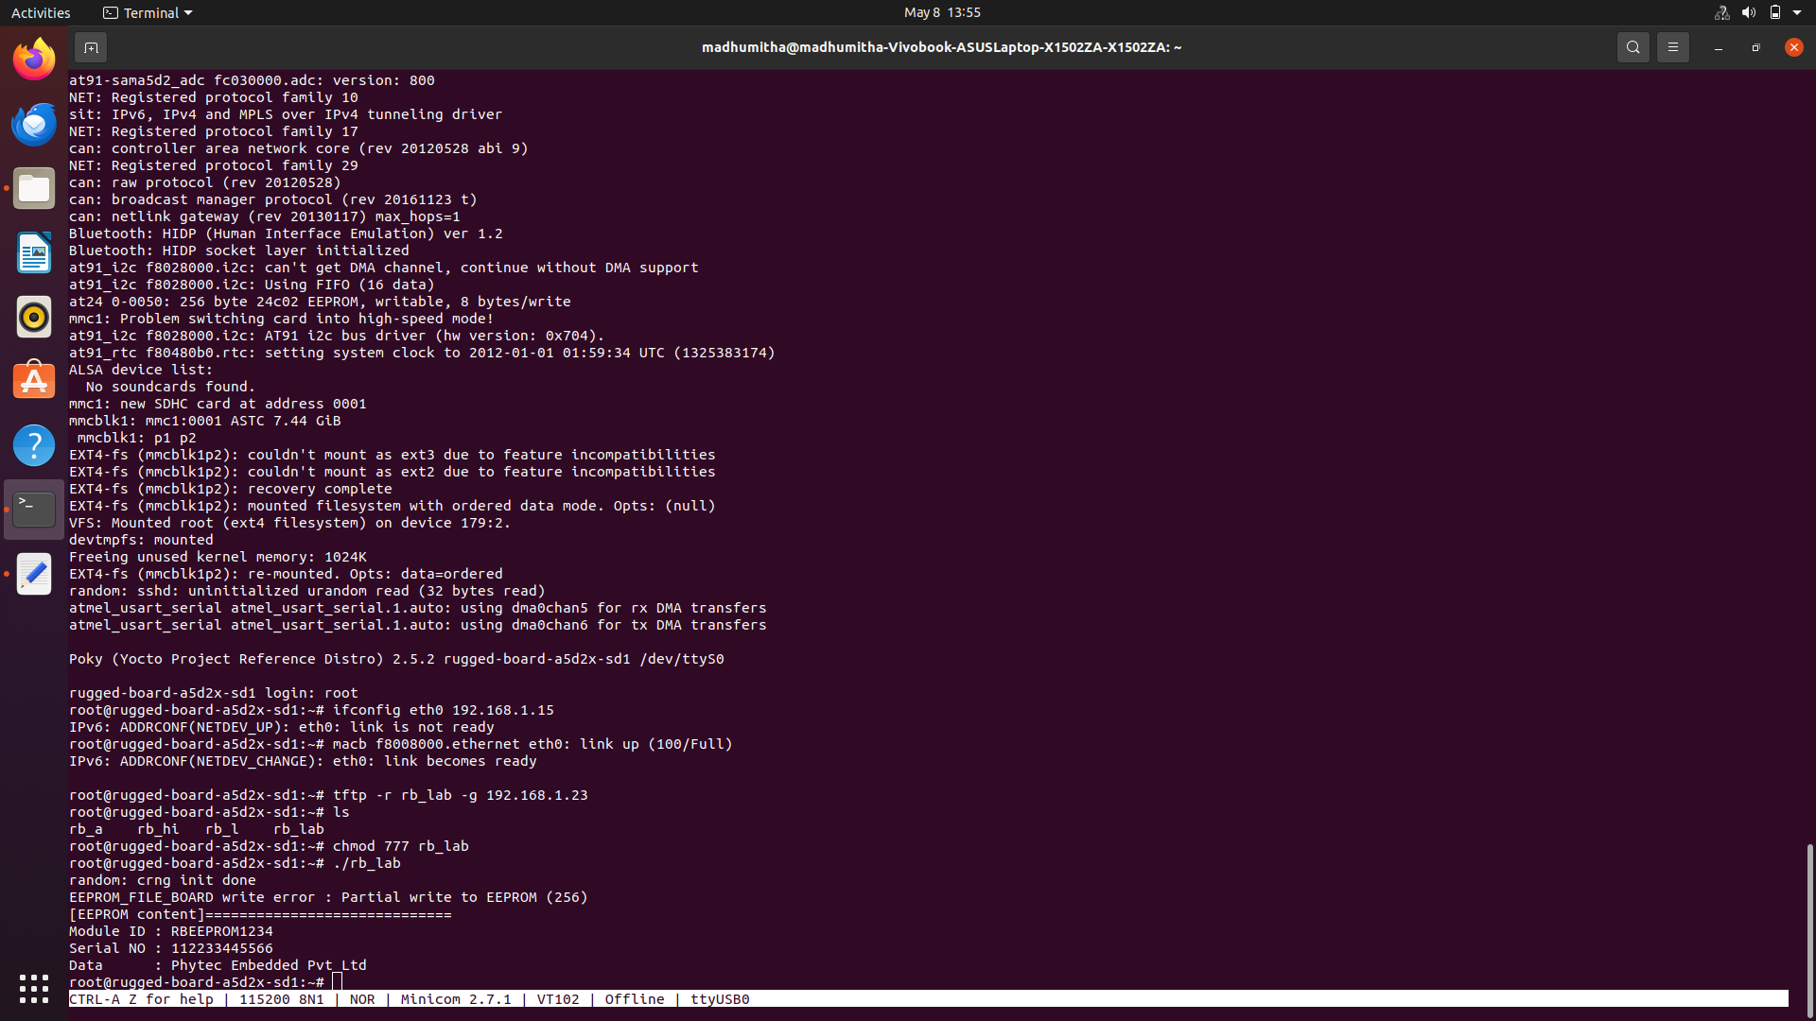

**RESULT:**

|  |  |
| --- | --- |
| Ex.no:  Date: | **Interface an Lcd to rugged board using**  **12c interface to display the Name & Regno** |

**AIM:**

To interface an lcd to rugged board using 12c interface to display the name & regnum.

**ALGORITHM:**

Step -1: Start the process.

Step -2: Power on the A5D2x board and ensure all necessary peripherals are connected, including the LCD module.

Step -3: Create three C files (.c) with the name main.c , LiqudCrystal_PCF8574.c , i2c-dev.c.

Step-4: Cross compile all the three .c files nd name the file.

Step-5: Open new terminal and open minicom and login as the root user.

Step-6: Enter ifconfig eth0 and your board IP Address.

Step-7: Enter tftp -r filename -g board IP Address.

Step-8: Enable the file by usng chmod 777 filename.

Step-9: Execute the file and the entered name and register number is displayed in the LCD.

**PROGRAM:**

**i2c-dev.c :**

#include "i2c-dev.h"

**LiqudCrystal_PCF8574.c :**

#include "LiquidCrystal_PCF8574.h"

#include "stdint.h"

#include <math.h>

#include <signal.h>

#include <stdio.h>

#include <stdlib.h>

#include <unistd.h>

#include <linux/types.h>

#include <sys/ioctl.h>

#include<string.h>

#include<fcntl.h>

#define SLAVE_ADDRESS_LCD (0x27) // change this according to ur setup

int i2c_dev_node;

int i2c_init(void)

{

char i2c_dev_node_path[] = "/dev/i2c-0";

int ret_val = 0;

i2c_dev_node = open(i2c_dev_node_path, O_RDWR);

if (i2c_dev_node < 0)

{

perror("Unable to open device node.");

exit(1);

}

ret_val = ioctl(i2c_dev_node,I2C_SLAVE,SLAVE_ADDRESS_LCD);

if (ret_val < 0)

{

perror("Could not set I2C_SLAVE.");

exit(2);

}

}

void lcd_write_i2c(int i2c,__u8 *buffer, __u8 length)

{

int ret_val = 0;

ret_val=i2c_smbus_write_block_data(i2c, 0x00,length, buffer);

if (ret_val < 0)

{

perror("Could not write data");

exit(2);

}

}

void lcd_send_cmd (char cmd)

{

char data_u, data_l;

uint8_t data_t[4];

data_u = (cmd&0xf0);

data_l = ((cmd<<4)&0xf0);

data_t[0] = data_u|0x0C; //en=1, rs=0

data_t[1] = data_u|0x08; //en=0, rs=0

data_t[2] = data_l|0x0C; //en=1, rs=0

data_t[3] = data_l|0x08; //en=0, rs=0

lcd_write_i2c(i2c_dev_node,(__u8 *)data_t,4);

}

void lcd_send_data (char data)

{

char data_u, data_l;

uint8_t data_t[4];

data_u = (data&0xf0);

data_l = ((data<<4)&0xf0);

data_t[0] = data_u|0x0D; //en=1, rs=1

data_t[1] = data_u|0x09; //en=0, rs=1

data_t[2] = data_l|0x0D; //en=1, rs=1

data_t[3] = data_l|0x09; //en=0, rs=1

lcd_write_i2c(i2c_dev_node,(__u8 *)data_t,4);

}

void setCursor(int a, int b)

{

int i=0;

switch(b){

case 0:lcd_send_cmd(0x80);break;

case 1:lcd_send_cmd(0xC0);break;

case 2:lcd_send_cmd(0x94);break;

case 3:lcd_send_cmd(0xd4);break;}

for(i=0;i<a;i++)

lcd_send_cmd(0x14);

}

void lcd_send_string (char *str)

{

while (*str) lcd_send_data (*str++);

}

void lcd_init (void)

{

i2c_init();

// 4 bit initialisation

usleep(50000); // wait for >40ms

lcd_send_cmd (0x3);

usleep(5000); // wait for >4.1ms

lcd_send_cmd (0x3);

usleep(110); // wait for >100us

lcd_send_cmd (0x3);

usleep(10000);

lcd_send_cmd (0x2); // 4bit mode

usleep(10000);

// dislay initialisation

lcd_send_cmd (0x28); // Function set --> DL=0 (4 bit mode), N = 1 (2 line display) F = 0 (5x8 characters)

usleep(1000);

lcd_send_cmd (0x08); //Display on/off control --> D=0,C=0, B=0 ---> display off

usleep(1000);

lcd_send_cmd (0x01); // clear display

usleep(1000);

usleep(1000);

lcd_send_cmd (0x06); //Entry mode set --> I/D = 1 (increment cursor) & S = 0 (no shift)

usleep(1000);

lcd_send_cmd (0x0C); //Display on/off control --> D = 1, C and B = 0. (Cursor and blink, last two bits)

}

void lcd_clear (void)

{

#define LCD_CLEARDISPLAY 0x01

lcd_send_cmd(LCD_CLEARDISPLAY);

usleep(100000);

}

**main.c :**

#include "LiquidCrystal_PCF8574.h"

#include "stdio.h"

#include <unistd.h>

int main(void)

{

lcd_init();

setCursor(0,0);

lcd_send_string("Prog for I2C on");

setCursor(0,1);

lcd_send_string("STM32F411RE");

usleep(2000000);

lcd_clear();

while(1)

{

setCursor(0,0);

lcd_send_string("DEVA");

setCursor(0,1);

lcd_send_string("SHIVA");

usleep(1000000);

}

}

**OUTPUT :**

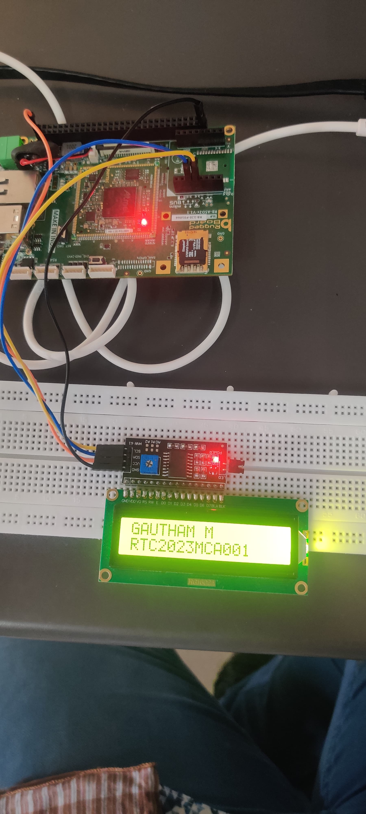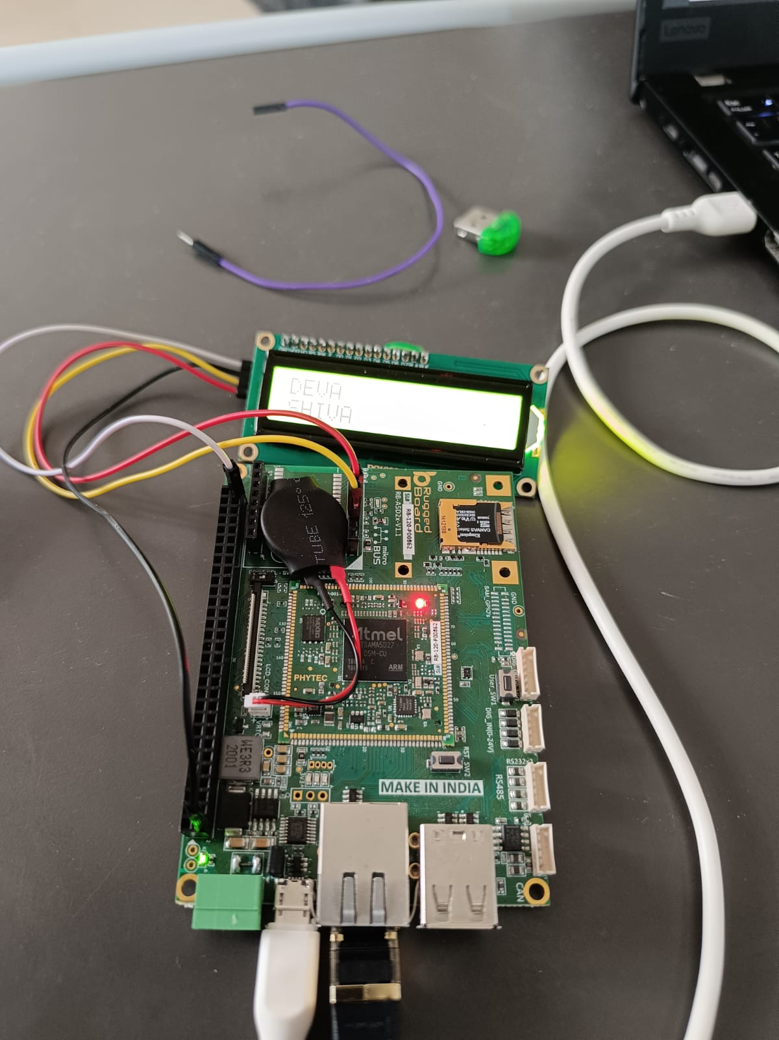

**RESULT :**

|  |  |
| --- | --- |
| Ex.no:  Date: | **A User space program to test the SPI present in the Microbus connector of RBA5D2X** |

**AIM:**

To write a user space program to test the SPI present in the micro bus connector.

**ALGORITHM:**

STEP 1: Start the program.

STEP 2: Include all necessary for SPI communication and other standard

functionalities.

STEP 3: Macro “ARRAY_SIZE” is defined to calculate the number of elements in an

array.

STEP 4: “pabort” function is defined for error handling. It prints an error message and

aborts the program.

STEP 5: Several global variables including the SPI device path, SPI mode, bits per

word, speed, delay and file paths for input and output.

STEP 6: Default transmit(“default_tx”) and receive(“default_rx”)buffers are defined.

STEP 7: “hex_dump”,”unescape” and “transfer” helper functions are defined.

STEP 8: It parses command-line options, opens the SPI device, sets SPI mode, bits

per word, and max speed. It then performs SPI transfer based on the selected

options (input_tx, input_file, or default transmit buffer). Finally, it closes the

SPI device and returns.

STEP 9: Stop the program.

**PROGRAM:**

**SPI.C**

#include "spi.h"

#include <stdio.h>

#include <stdlib.h>

#include <string.h>

#include <getopt.h>

#include <unistd.h>

#include <fcntl.h>

#include <sys/ioctl.h>

#include <linux/ioctl.h>

#include <sys/stat.h>

#define ARRAY_SIZE(a) (sizeof(a) / sizeof((a)[0]))

void pabort(const char *s) {

perror(s);

abort();

}

void hex_dump(const void *src, size_t length, size_t line_size, char *prefix) {

int i = 0;

const unsigned char *address = src;

const unsigned char *line = address;

unsigned char c;

printf("%s | ", prefix);

while (length-- > 0) {

printf("%02X ", *address++);

if (!(++i % line_size) || (length == 0 && i % line_size)) {

if (length == 0) {

while (i++ % line_size)

printf("__ ");

}

printf(" | "); /* right close */

while (line < address) {

c = *line++;

printf("%c", (c < 33 || c == 255) ? 0x2E : c);

}

printf("\n");

if (length > 0)

printf("%s | ", prefix);

}

}

}

int unescape(char *_dst, char *_src, size_t len) {

int ret = 0;

int match;

char *src = _src;

char *dst = _dst;

unsigned int ch;

while (*src) {

if (*src == '\\' && *(src+1) == 'x') {

match = sscanf(src + 2, "%2x", &ch);

if (!match)

pabort("malformed input string");

src += 4;

*dst++ = (unsigned char)ch;

} else {

*dst++ = *src++;

}

ret++;

}

return ret;

}

void transfer(int fd, uint8_t const *tx, uint8_t const *rx, size_t len) {

int ret;

int out_fd;

struct spi_ioc_transfer tr = {

.tx_buf = (unsigned long)tx,

.rx_buf = (unsigned long)rx,

.len = len,

.delay_usecs = delay,

.speed_hz = speed,

.bits_per_word = bits,

};

if (mode & SPI_TX_QUAD)

tr.tx_nbits = 4;

else if (mode & SPI_TX_DUAL)

tr.tx_nbits = 2;

if (mode & SPI_RX_QUAD)

tr.rx_nbits = 4;

else if (mode & SPI_RX_DUAL)

tr.rx_nbits = 2;

if (!(mode & SPI_LOOP)) {

if (mode & (SPI_TX_QUAD | SPI_TX_DUAL))

tr.rx_buf = 0;

else if (mode & (SPI_RX_QUAD | SPI_RX_DUAL))

tr.tx_buf = 0;

}

ret = ioctl(fd, SPI_IOC_MESSAGE(1), &tr);

if (ret < 1)

pabort("can't send spi message");

if (verbose)

hex_dump(tx, len, 32, "TX");

if (output_file) {

out_fd = open(output_file, O_WRONLY | O_CREAT | O_TRUNC, 0666);

if (out_fd < 0)

pabort("could not open output file");

ret = write(out_fd, rx, len);

if (ret != len)

pabort("not all bytes written to output file");

close(out_fd);

}

if (verbose || !output_file)

hex_dump(rx, len, 32, "RX");

}

void parse_opts(int argc, char *argv[]) {

while (1) {

static const struct option lopts[] = {

{ "device", 1, 0, 'D' },

{ "speed", 1, 0, 's' },

{ "delay", 1, 0, 'd' },

{ "bpw", 1, 0, 'b' },

{ "input", 1, 0, 'i' },

{ "output", 1, 0, 'o' },

{ "loop", 0, 0, 'l' },

{ "cpha", 0, 0, 'H' },

{ "cpol", 0, 0, 'O' },

{ "lsb", 0, 0, 'L' },

{ "cs-high", 0, 0, 'C' },

{ "3wire", 0, 0, '3' },

{ "no-cs", 0, 0, 'N' },

{ "ready", 0, 0, 'R' },

{ "dual", 0, 0, '2' },

{ "verbose", 0, 0, 'v' },

{ "quad", 0, 0, '4' },

{ NULL, 0, 0, 0 },

};

int c;

c = getopt_long(argc, argv, "D:s:d:b:i:o:lHOLC3NR24p:v",

lopts, NULL);

if (c == -1)

break;

switch (c) {

case 'D':

device = optarg;

break;

case 's':

speed = atoi(optarg);

break;

case 'd':

delay = atoi(optarg);

break;

case 'b':

bits = atoi(optarg);

break;

case 'i':

input_file = optarg;

break;

case 'o':

output_file = optarg;

break;

case 'l':

mode |= SPI_LOOP;

break;

case 'H':

mode |= SPI_CPHA;

break;

case 'O':

mode |= SPI_CPOL;

break;

case 'L':

mode |= SPI_LSB_FIRST;

break;

case 'C':

mode |= SPI_CS_HIGH;

break;

case '3':

mode |= SPI_3WIRE;

break;

case 'N':

mode |= SPI_NO_CS;

break;

case 'v':

verbose = 1;

break;

case 'R':

mode |= SPI_READY;

break;

case 'p':

input_tx = optarg;

break;

case '2':

mode |= SPI_TX_DUAL;

break;

case '4':

mode |= SPI_TX_QUAD;

break;

default:

print_usage(argv[0]);

break;

}

}

if (mode & SPI_LOOP) {

if (mode & SPI_TX_DUAL)

mode |= SPI_RX_DUAL;

if (mode & SPI_TX_QUAD)

mode |= SPI_RX_QUAD;

}

}

void print_usage(const char *prog) {

printf("Usage: %s [-DsbdlHOLC3]\n", prog);

puts(" -D --device device to use (default /dev/spidev1.1)\n"

" -s --speed max speed (Hz)\n"

" -d --delay delay (usec)\n"

" -b --bpw bits per word\n"

" -i --input input data from a file (e.g. \"test.bin\")\n"

" -o --output output data to a file (e.g. \"results.bin\")\n"

" -l --loop loopback\n"

" -H --cpha clock phase\n"

" -O --cpol clock polarity\n"

" -L --lsb least significant bit first\n"

" -C --cs-high chip select active high\n"

" -3 --3wire SI/SO signals shared\n"

" -v --verbose Verbose (show tx buffer)\n"

" -p Send data (e.g. \"1234\\xde\\xad\")\n"

" -N --no-cs no chip select\n"

" -R --ready slave pulls low to pause\n"

" -2 --dual dual transfer\n"

" -4 --quad quad transfer\n");

exit(1);

}

void transfer_escaped_string(int fd, char *str) {

size_t size = strlen(str);

uint8_t *tx;

uint8_t *rx;

tx = malloc(size);

if (!tx)

pabort("can't allocate tx buffer");

rx = malloc(size);

if (!rx)

pabort("can't allocate rx buffer");

size = unescape((char *)tx, str, size);

transfer(fd, tx, rx, size);

free(rx);

free(tx);

}

void transfer_file(int fd, char *filename) {

ssize_t bytes;

struct stat sb;

int tx_fd;

uint8_t *tx;

uint8_t *rx;

if (stat(filename, &sb) == -1)

pabort("can't stat input file");

tx_fd = open(filename, O_RDONLY);

if (fd < 0)

pabort("can't open input file");

tx = malloc(sb.st_size);

if (!tx)

pabort("can't allocate tx buffer");

rx = malloc(sb.st_size);

if (!rx)

pabort("can't allocate rx buffer");

bytes = read(tx_fd, tx, sb.st_size);

if (bytes != sb.st_size)

pabort("failed to read input file");

transfer(fd, tx, rx, sb.st_size);

free(rx);

free(tx);

 close(tx_fd);

}

**SPI.h :**

#ifndef SPI_H

#define SPI_H

#include <stdint.h>

#define ARRAY_SIZE(a) (sizeof(a) / sizeof((a)[0]))

void pabort(const char *s);

void hex_dump(const void *src, size_t length, size_t line_size, char *prefix);

int unescape(char *_dst, char *_src, size_t len);

void transfer(int fd, uint8_t const *tx, uint8_t const *rx, size_t len);

void parse_opts(int argc, char *argv[]);

void transfer_escaped_string(int fd, char *str);

void transfer_file(int fd, char *filename);

#endif /* SPI_H */

**SPI_main.c :**

#include "spi.h"

#include <stdio.h>

static const char *device = "/dev/spidev3.0";

static uint32_t mode;

static uint8_t bits = 8;

static char *input_file;

static char *output_file;

static uint32_t speed = 500000;

static uint16_t delay;

static int verbose;

uint8_t default_tx[] = {

0xFF, 0xFF, 0xFF, 0xFF, 0xFF, 0xFF,

0x40, 0x00, 0x00, 0x00, 0x00, 0x95,

0xFF, 0xFF, 0xFF, 0xFF, 0xFF, 0xFF,

0xFF, 0xFF, 0xFF, 0xFF, 0xFF, 0xFF,

0xFF, 0xFF, 0xFF, 0xFF, 0xFF, 0xFF,

0xF0, 0x0D,

};

uint8_t default_rx[ARRAY_SIZE(default_tx)] = {0, };

char *input_tx;

int main(int argc, char *argv[]) {

int ret = 0;

int fd;

parse_opts(argc, argv);

fd = open(device, O_RDWR);

if (fd < 0)

pabort("can't open device");

/*

* spi mode

*/

ret = ioctl(fd, SPI_IOC_WR_MODE32, &mode);

if (ret == -1)

pabort("can't set spi mode");

ret = ioctl(fd, SPI_IOC_RD_MODE32, &mode);

if (ret == -1)

pabort("can't get spi mode");

/*

* bits per word

*/

ret = ioctl(fd, SPI_IOC_WR_BITS_PER_WORD, &bits);

if (ret == -1)

pabort("can't set bits per word");

ret = ioctl(fd, SPI_IOC_RD_BITS_PER_WORD, &bits);

if (ret == -1)

pabort("can't get bits per word");

/*

* max speed hz

*/

ret = ioctl(fd, SPI_IOC_WR_MAX_SPEED_HZ, &speed);

if (ret == -1)

pabort("can't set max speed hz");

ret = ioctl(fd, SPI_IOC_RD_MAX_SPEED_HZ, &speed);

if (ret == -1)

pabort("can't get max speed hz");

printf("spi mode: 0x%x\n", mode);

printf("bits per word: %d\n", bits);

printf("max speed: %d Hz (%d KHz)\n", speed, speed/1000);

if (input_tx && input_file)

pabort("only one of -p and --input may be selected");

if (input_tx)

transfer_escaped_string(fd, input_tx);

else if (input_file)

transfer_file(fd, input_file);

else

transfer(fd, default_tx, default_rx, sizeof(default_tx));

close(fd);

   return ret;

}

**OUTPUT:**

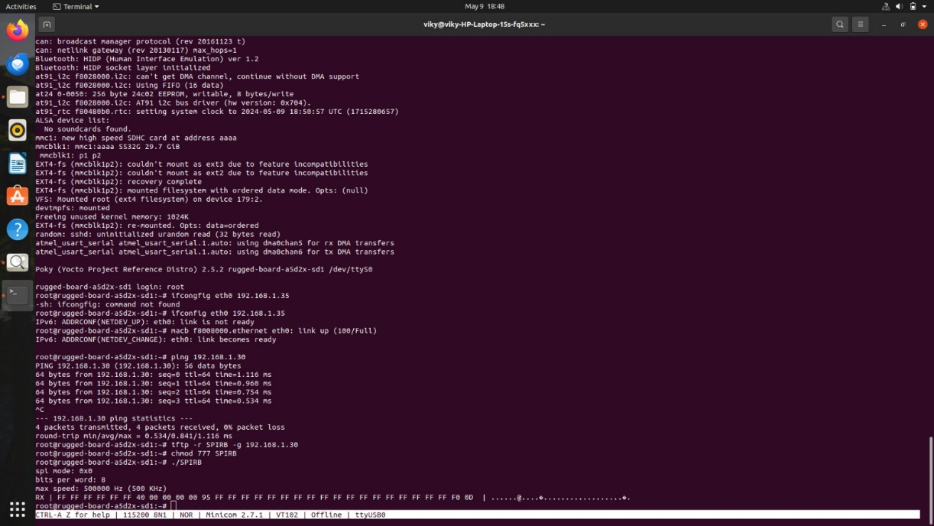

**RESULT:**

|  |  |
| --- | --- |
| Ex.no:  Date: | **ANALOG TO DIGITAL CONVERTOR** |

**AIM:**

This application is to read the Analog data using ADC interface via /sys/fs entries.

**ALGORITHM:**

STEP 1: Start the process.

STEP 2: Open a terminal or command prompt. Navigate to the directory where you saved

STEP 3: Compile the program using a C compiler such as GCC.

STEP 4: Convert into tftp file in copy their file and using ethernet cable to use target terminal to given the commands to run it .

STEP 5: After successful compilation, run the program by executing the following command

./adc_test <ADC_CHANNEL_NUMBER>

STEP 6: For example, to read from ADC channel 0, you would run

./adc_test 0

STEP 7: Stop the program.

**PROGRAM:**

**Test.c**

#include <stdio.h>

#include <stdlib.h>

#include <string.h>

#include <errno.h>

#include <unistd.h>

#include <fcntl.h>

#include "adc.h"

/****************************************

MAIN

*****************************************/

int main(int argc, char **argv, char **envp)

{

int digital_val;

struct adc_config_t adc_desc;

float analog_val;

adc_desc.adc_mode = ONESHOT;

adc_desc.capture = 0;

adc_desc.buff_length = 100;

adc_desc.adc_channel = atoi(argv[1]);

printf("\n *** ADC TESTING UTILITY *** \n");

adc_init(&adc_desc);

adc_set_channel(&adc_desc, adc_desc.adc_channel);

while (1)

{

digital_val = adc_output(&adc_desc, adc_desc.adc_channel);

analog_val = (digital_val * 0.805664062)/4095;

printf("Digital Value on Channel %d = %d\n", adc_desc.adc_channel, digital_val);

printf("Analog Value on Channel %d = %f\n", adc_desc.adc_channel, analog_val);

sleep(1);

}

return 0;

}

**ADC.h**

#ifndef _ADC_H

#define _ADC_H

#define ONESHOT "oneshot"

#define CONTINUOUS "continuous"

struct adc_config_t

char *adc_mode;

/* ADC mode - oneshot or continuous*/

int capture;

/* 1 - Enable buffer 0 - disable buffer */

unsigned int buff_length; /* buffer length */

int adc_channel;

/* ADC channel to use (0-7) */

unsigned char buf[100];

};

/* Below Functions used in ADC - Library/Test-Program */

int adc_init(struct adc_config_t *);

int adc_set_channel(struct adc_config_t *, int);

int adc_output(struct adc_config_t *, int);

#endif

**ADC.c**

#include <stdio.h>

#include <stdlib.h>

#include <string.h>

#include <errno.h>

#include <unistd.h>

#include <fcntl.h>

#include "adc.h"

/* ADC - Initialization */

int adc_init(struct adc_config_t *adc_desc)

{

/* Set ADC mode */

int mode_fd;

//mode_fd = open("/sys/bus/iio/devices/iio:device0/in_conversion_mode", O_WRONLY);

//write(mode_fd, (char *)adc_desc->adc_mode, 10);

//close(mode_fd);

/* ADC - Enable or disable buffer */

int capture_fd;

//capture_fd = open("/sys/bus/iio/devices/iio:device0/buffer/enable", O_WRONLY);

capture_fd = open("/sys/bus/iio/devices/iio:device0/buffer/enable", O_WRONLY);

if(capture_fd < 0 )

{

perror("open buffer enable error");

}

if(adc_desc->capture)

write(capture_fd, "1", 2);

else

write(capture_fd, "0", 2);

close(capture_fd);

/* ADC - SET BUFFER LENGTH */

int length_fd;

//length_fd = open("/sys/bus/iio/devices/iio:device0/buffer/length", O_WRONLY);

length_fd = open("/sys/bus/iio/devices/iio:device0/buffer/length", O_WRONLY);

if(length_fd < 0 )

{

perror("open buffer length error");

}

snprintf(adc_desc->buf, sizeof(adc_desc->buff_length), "%d", adc_desc->buff_length);

write(length_fd, adc_desc->buf, strlen(adc_desc->buf));

close(length_fd);

return 0;

}

/* ADC - SET CHANNEL */

int adc_set_channel(struct adc_config_t *adc_desc, int channel)

{

int channel_fd;

//sprintf(adc_desc->buf, "/sys/bus/iio/devices/iio:device0/scan_elements/in_voltage%d_en", channel);

sprintf(adc_desc->buf, "/sys/bus/iio/devices/iio:device0/scan_elements/in_voltage%d_en", channel);

channel_fd = open(adc_desc->buf, O_WRONLY);

if(channel_fd < 0 )

{

perror("open scan_elements/in_voltage6_en error");

}

write(channel_fd, "1", 2);

close(channel_fd);

return 0;

}

/* ADC - READ OUTPUT DATA */

int adc_output(struct adc_config_t *adc_desc, int channel)

{

int output_fd, adc_data;

char result[10], ret=0;

//sprintf(adc_desc->buf, "/sys/bus/iio/devices/iio:device0/in_voltage%d_raw", channel);

sprintf(adc_desc->buf, "/sys/bus/iio/devices/iio:device0/in_voltage%d_raw", channel);

output_fd = open(adc_desc->buf, O_RDONLY);

if(output_fd < 0 )

{

perror("open in_voltage6_raw error");

}

ret = read(output_fd, result, sizeof(result));

adc_data = atoi(result);

close(output_fd);

return adc_data;

}

**OUTPUT:**

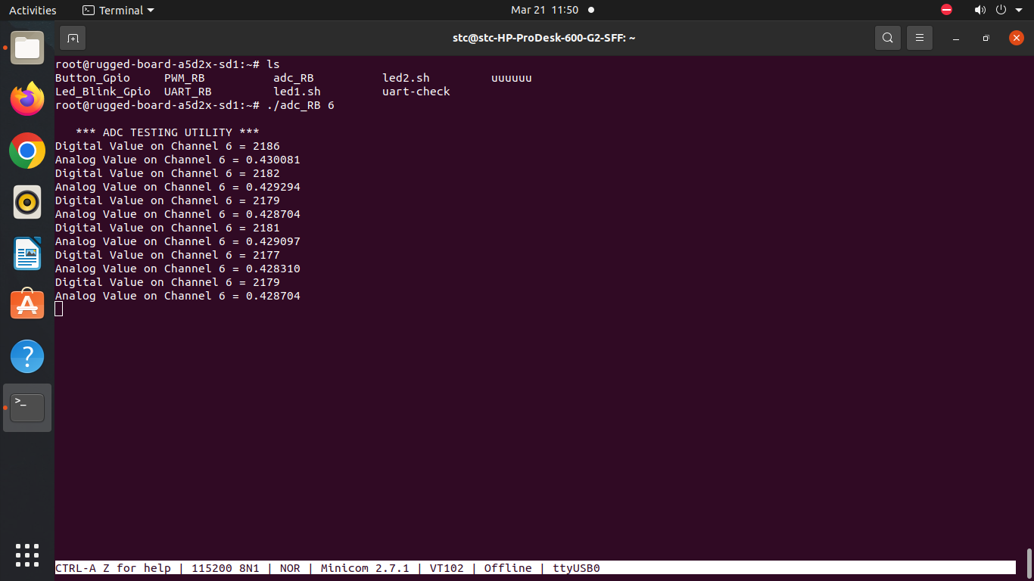

**RESULT :**

|  |  |
| --- | --- |
| Ex.no:  Date: | **Control the intensity of an LED using PWM.** |

**AIM:**

To control the intensity of an LED using PWM.

**ALGORITHM:**

STEP 1 : Start the process.

STEP 2: Include standard C libraries like stdio.h, stdlib.h, string.h, fcntl.h, unistd.h, and time.h.

STEP 3: Declare Global Variables like export_path, pwm_periods, pwm_enable, duty_cycle: paths to the PWM sysfs files.

STEP 4: Takes command-line arguments for the period and duty cycle.

STEP 5: Open and write to the export_path to export the PWM pin.

STEP 6: Open and write the period value (from command-line argument) to pwm_periods.

STEP 7: Set Duty Cycle and Generate PWM Signal

STEP 8: Close all file descriptors after use.

STEP 9: Stop the process.

RTC_CR_BYPSHAD.

STEP 9: Clear Initialization Flag

- Clear initialization flag (RTC_ISR_INIT) to indicate end of RTC initialization.

STEP 10: Disable Access to RTC Registers

- Disable access to RTC registers to prevent unintended writes by clearing PWR_CR_DBP.

**PROGRAM:**

**PWM_controller.h:**

#ifndef PWM_CONTROLLER_H

#define PWM_CONTROLLER_H

// Function prototypes

void export_pwm_pin();

void set_pwm_period(int period);

void enable_pwm();

void generate_pwm_signal(int period, int initial_duty_cycle);

#endif

**PWM_controller.c:**

#include "pwm_controller.h"

#include <stdio.h>

#include <stdlib.h>

#include <string.h>

#include <fcntl.h>

#include <unistd.h>

char export_path[] = "/sys/class/pwm/pwmchip0/export";

char pwm_periods[] = "/sys/class/pwm/pwmchip0/pwm1/period";

char pwm_enable[] = "/sys/class/pwm/pwmchip0/pwm1/enable";

char duty_cycle[] = "/sys/class/pwm/pwmchip0/pwm1/duty_cycle";

void export_pwm_pin() {

int fd = open(export_path, O_WRONLY);

if (fd < 0) {

perror("export path error \n");

exit(1);

}

write(fd, "1", 2);

close(fd);

}

void set_pwm_period(int period) {

int fd = open(pwm_periods, O_WRONLY);

if (fd < 0) {

perror("period error \n");

exit(1);

}

char period_str[5];

snprintf(period_str, sizeof(period_str), "%d", period);

write(fd, period_str, strlen(period_str));

close(fd);

}

void enable_pwm() {

int fd = open(pwm_enable, O_WRONLY);

if (fd < 0) {

perror("enable error \n");

exit(1);

}

write(fd, "1", 2);

close(fd);

}

void generate_pwm_signal(int period, int initial_duty_cycle) {

int fd = open(duty_cycle, O_WRONLY);

if (fd < 0) {

perror("duty cycle error \n");

exit(1);

}

int value = initial_duty_cycle;

char value_str[5];

while (1) {

snprintf(value_str, sizeof(value_str), "%d", value);

write(fd, value_str, strlen(value_str));

printf("pwm value : %d \n", value);

value++;

usleep(100000);

if (value >= period) {

value = 0;

}

}

close(fd);

}

**Main.c:**

#include "pwm_controller.h"

int main(int argc, char **argv) {

if (argc != 3) {

printf("Usage: %s <period> <initial_duty_cycle>\n", argv[0]);

return 1;

}

int period = atoi(argv[1]);

int initial_duty_cycle = atoi(argv[2]);

export_pwm_pin();

set_pwm_period(period);

enable_pwm();

generate_pwm_signal(period, initial_duty_cycle);

return 0;

}

**OUTPUT:**

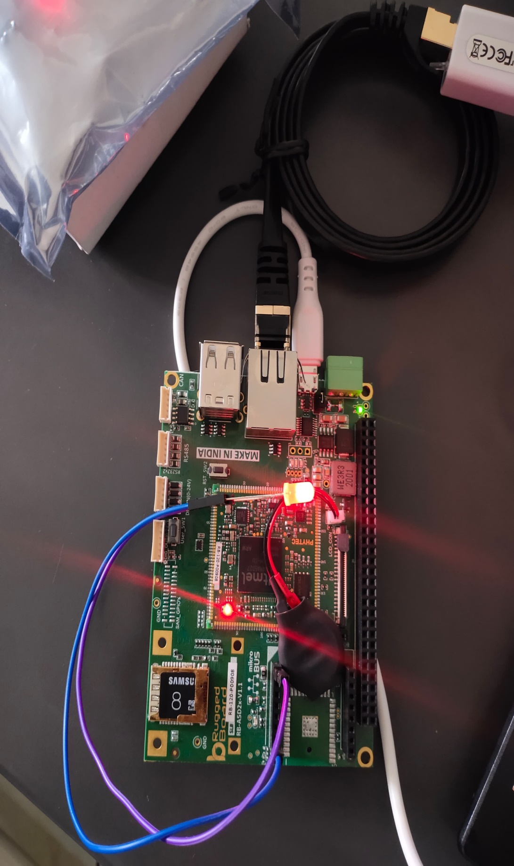

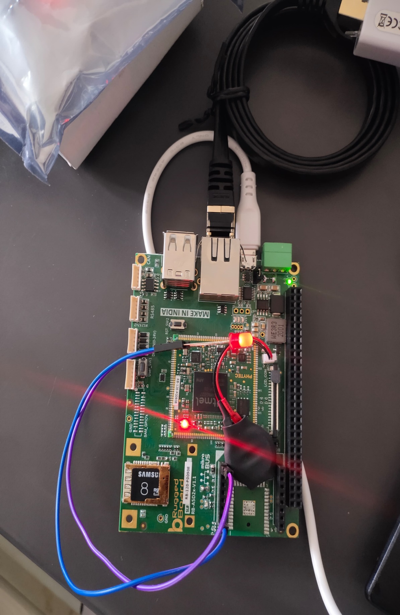

**RESULT :**

|  |  |
| --- | --- |
| Ex.no:  Date: | **A User space program for echo server**  **and test it in Rugged Board** |

**AIM :**

To write a user space program for echo server and test in RBA5T2X.

**ALGORITHM:**

**Echoserver:**

Step 1: Start the Program.

Step 2: Create a socket for the server (server_sockfd).

Step 3: Associate the server socket with a specific IP address and port (bind()).

Step 4: Mark the server socket as passive, indicating it will be used to accept incoming connections (listen()).

Step 5: Block until a client connection is established, then create a new socket (client_sockfd) for communication with the client (accept()).

Step 6: Continuously read data from the client and write it back to the client.

Step 7: Close the socket connection with the client.

Step 8: Go back to step 4 to accept and handle new client connections indefinitely.

Step 9: Stop the Program.

**Echoclient:**

Step 1: Start the program

Step 2: Check if the correct number of command-line arguments is provided. If not, print an error message and exit.

Step 3: Create a socket

Step 4: Set up the server’s address and port in a ‘sockaddr_in’ structure.

Step 5: Connect the socket to the server.

Step 6: Enter a loop:

* Read input from stdin.

*Send the input to the server.

*Read the response from the server.

*Print the response to stdout.

Step 7: Close the socket and exit the program.

Step 8: Stop the program.

**PROGRAM :**

**EchoServer:**

**server.h**

#ifndef SERVER_H

#define SERVER_H

#include <sys/types.h>

#include <sys/socket.h>

#include <netdb.h>

#include <netinet/in.h>

#include <arpa/inet.h>

#include <stdio.h>

#include <stdlib.h>

#include <unistd.h>

#include <string.h>

int create_server_socket();

void bind_server_socket(int server_sockfd, int port);

void listen_for_connections(int server_sockfd);

int accept_client_connection(int server_sockfd, struct sockaddr_in *client_addr);

void handle_client_connection(int client_sockfd);

#endif // SERVER_H

**server.c**

#include "server.h"

int create_server_socket() {

return socket(AF_INET, SOCK_STREAM, 0);

}

void bind_server_socket(int server_sockfd, int port) {

struct sockaddr_in server_addr;

server_addr.sin_family = AF_INET;

server_addr.sin_port = htons(port);

inet_aton("130.0.12.164", &server_addr.sin_addr);

memset(&(server_addr.sin_zero), '\0', sizeof server_addr.sin_zero);

bind(server_sockfd, (struct sockaddr*)&server_addr, sizeof server_addr);

}

void listen_for_connections(int server_sockfd) {

listen(server_sockfd, 10);

}

int accept_client_connection(int server_sockfd, struct sockaddr_in *client_addr) {

int client_sockfd;

int client_len = sizeof *client_addr;

client_sockfd = accept(server_sockfd, (struct sockaddr*)client_addr, &client_len);

return client_sockfd;

}

void handle_client_connection(int client_sockfd) {

char buf[100];

int rv;

while ((rv = read(client_sockfd, buf, sizeof buf)) > 0)

write(client_sockfd, buf, rv);

close(client_sockfd);

}

**main.c**

#include "server.h"

int main() {

int server_sockfd;

int client_sockfd;

struct sockaddr_in client_addr;

server_sockfd = create_server_socket();

bind_server_socket(server_sockfd, 54154);

listen_for_connections(server_sockfd);

while (1) {

fprintf(stderr, "\nServer waiting for client connection...");

client_sockfd = accept_client_connection(server_sockfd, &client_addr);

fprintf(stderr, "\n********* CLIENT CONNECTION ESTABLISHED ********");

handle_client_connection(client_sockfd);

fprintf(stderr, "\n********* CLIENT CONNECTION TERMINATED ********");

}

return 0;

}

**Echoclient:**

**Main.c**

#include “client.h”

Int main(int argc, char** argv) {

If (argc != 3) {

Printf(“Must enter IP and port\n”);

Exit(1);

}

Int sockfd = create_socket(argv[1], argv[2]);

Client_loop(sockfd);

Close(sockfd);

Exit(0);

}

**Client.h**

#ifndef CLIENT_H

#define CLIENT_H

#include <stdio.h>

#include <stdlib.h>

#include <unistd.h>

#include <string.h>

#include <sys/types.h>

#include <sys/socket.h>

#include <netdb.h>

#include <netinet/in.h>

#include <arpa/inet.h>

Int create_socket(const char *ip, const char *port);

Void client_loop(int sockfd);

#endif

**Client.c**

#include “client.h”

Int create_socket(const char *ip, const char *port) {

Int sockfd = socket(PF_INET, SOCK_STREAM, 0);

If (sockfd == -1) {

Perror(“socket”);

Exit(1);

}

Struct sockaddr_in dest_addr;

Dest_addr.sin_family = AF_INET;

Dest_addr.sin_port = htons(atoi(port));

Inet_aton(ip, &dest_addr.sin_addr);

Memset(&(dest_addr.sin_zero), ‘\0’, sizeof dest_addr.sin_zero);

If (connect(sockfd, (struct sockaddr*)&dest_addr, sizeof dest_addr) == -1) {

Perror(“connect”);

Exit(1);

}

Return sockfd;

}

Void client_loop(int sockfd) {

Char buff1[128], buff2[128];

While (1) {

Int n = read(0, buff1, sizeof buff1);

Buff1[n] = ‘\0’;

Write(sockfd, buff1, strlen(buff1));

N = read(sockfd, buff2, sizeof buff2);

Buff2[n] = ‘\0’;

Write(1, buff2, n);

}

}

**OUTPUT:**

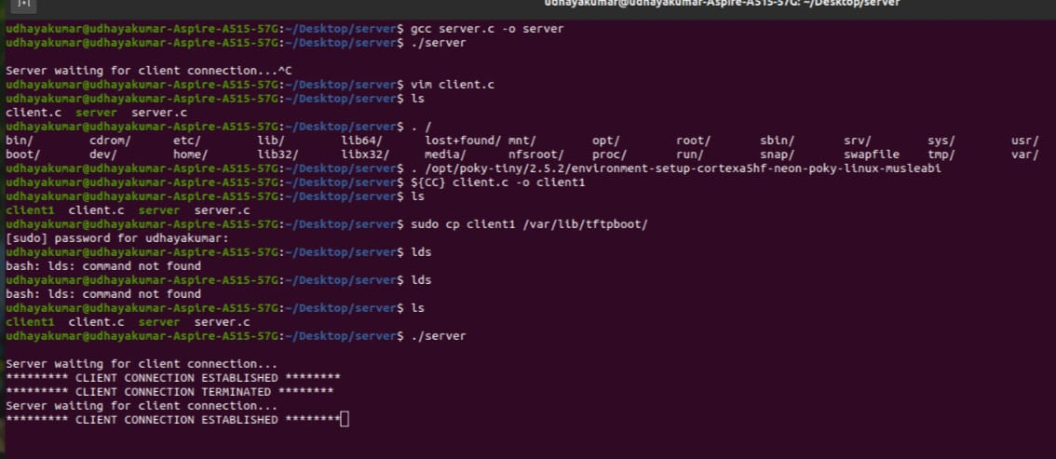

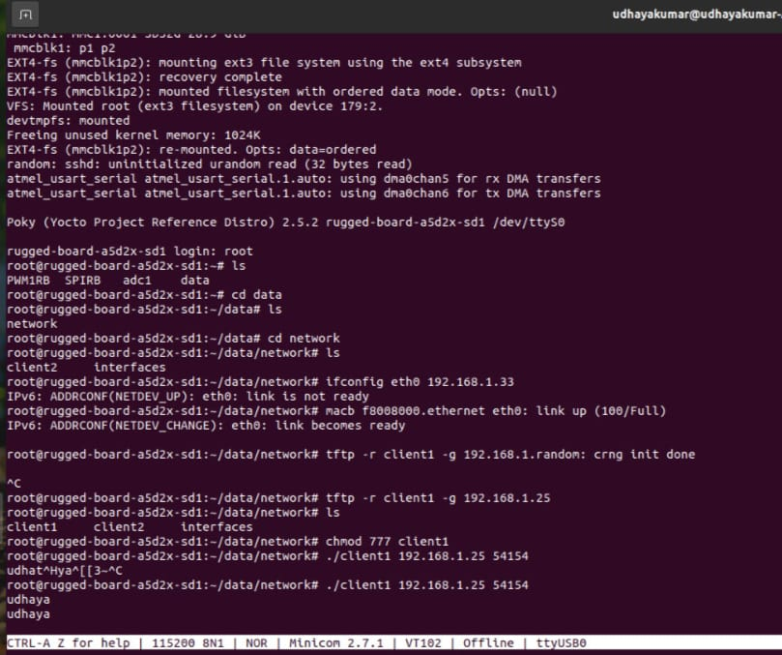

**RESULT:**